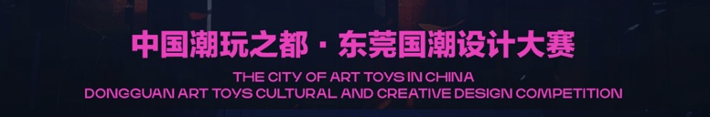
团队名称  Team name | （请填写公司/工作室/院校名称）  (Please fill in the name of your company/studio/institution)
作品名称
The title of works
团队负责人  Team leader | 姓名  Name | 联系电话  Mobile | 邮箱  Email | 单位/学校  Place of study or work
赛道报名选择  （请以√表明赛道选择）  Track Registration Options  ( Please indicate track choice with √) |  | 第一赛道：国风潮玩IP设计  Track 1: Chinese Style Art Toy IP Design
第二赛道：在地风物产品设计
Track 2: Local Cultural Products Design
共同参与第一、二赛道
Participate in the first and second track together
团队成员
Team members
参赛作品思路
（300字）
Ideas for entries
(300 words)
备注
Remarks

